FYP TESTING
Scenario: Student_Data_Breach.json (Juiciness: 98%)
ABM Agents: Agent_profiles(50).csv [50 agents]

Test convergence round 200

1. Zero Test
Parameters all set to -100%. (All parameters = 0)
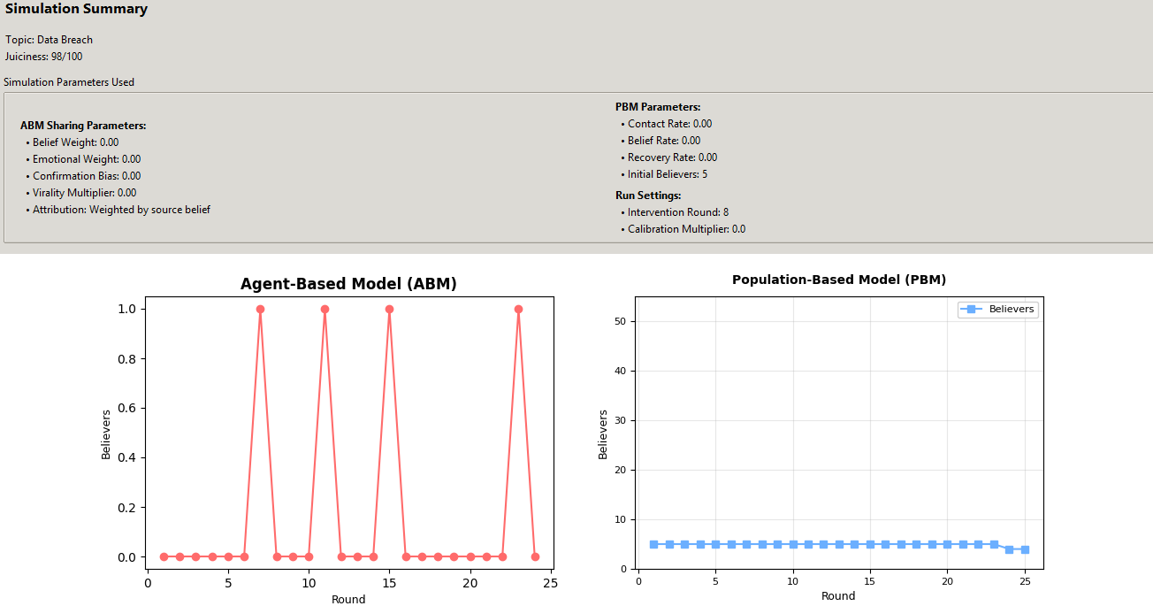
The PBM model reaches an equilibrium when the change in believers is zero (dY/dt = 0). This happens when NewBelievers - Recoveries = 0.

2. Default Test
Parameters all set to 0% (Default hardcoded parameters).

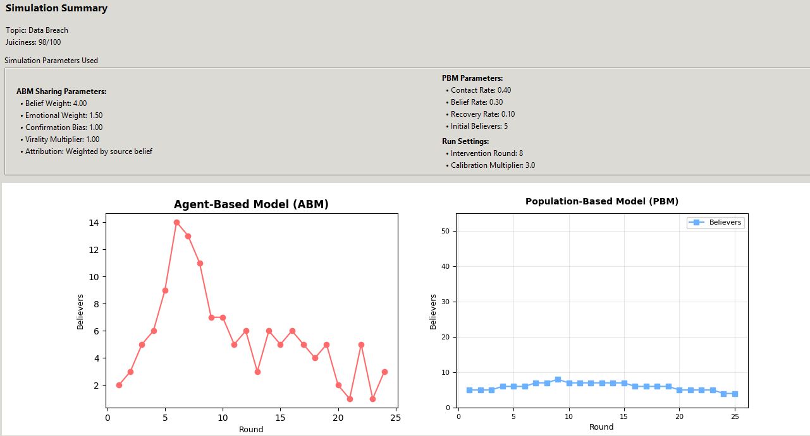
3. Stress Test
Parameters all set to max% (except min% recovery rate).
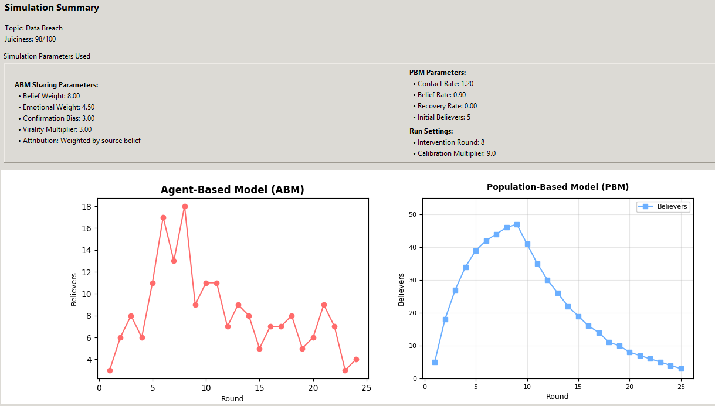
*It recovers after round 8 (intervention round)

4. Sensitivity Test (No intervention round)
- Belief Weight: 0. Other Parameters: 0.
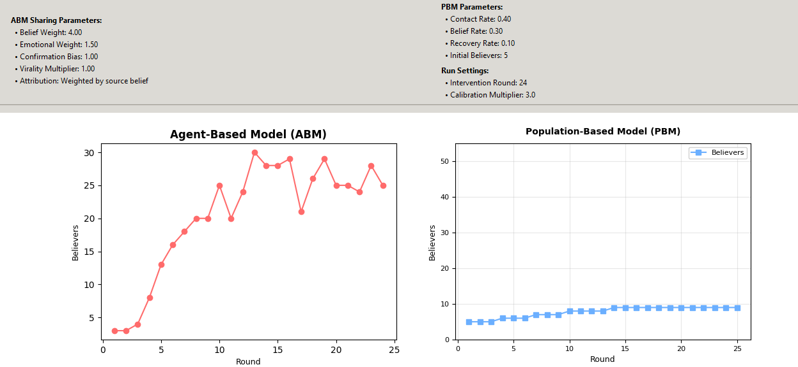

- ABM Belief Weight: 20%. PBM Belief Rate: 20% Other Parameters: 0.
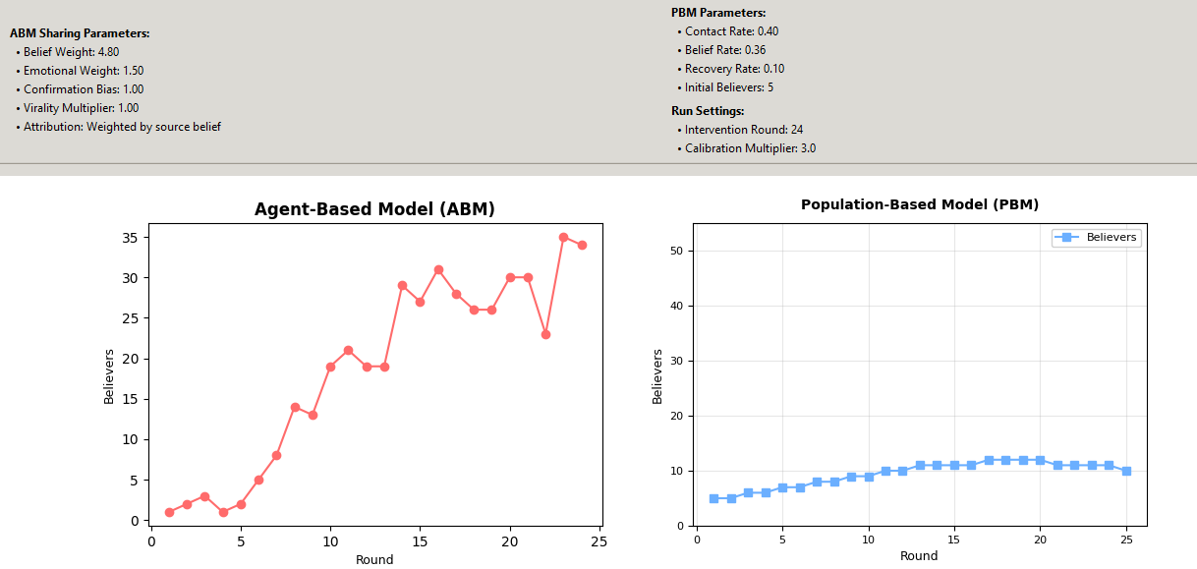

- Belief Weight: 40%. PBM Belief Rate: 40%. Other Parameters: 0
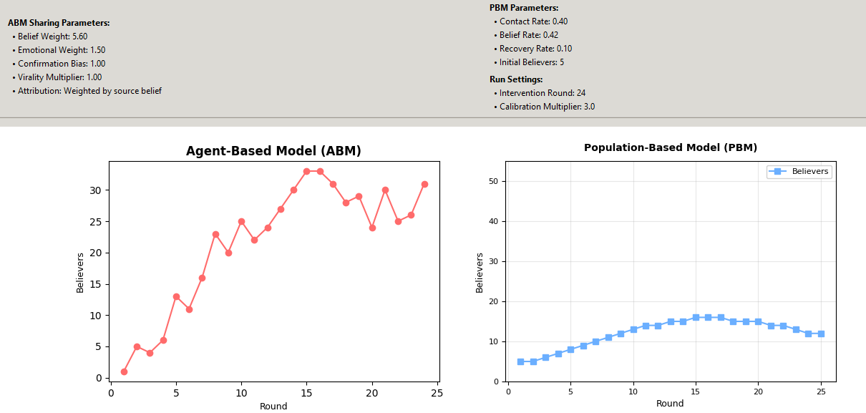

- Belief Weight: 60%. PBM Belief Rate: 60%. Other Parameters: 0
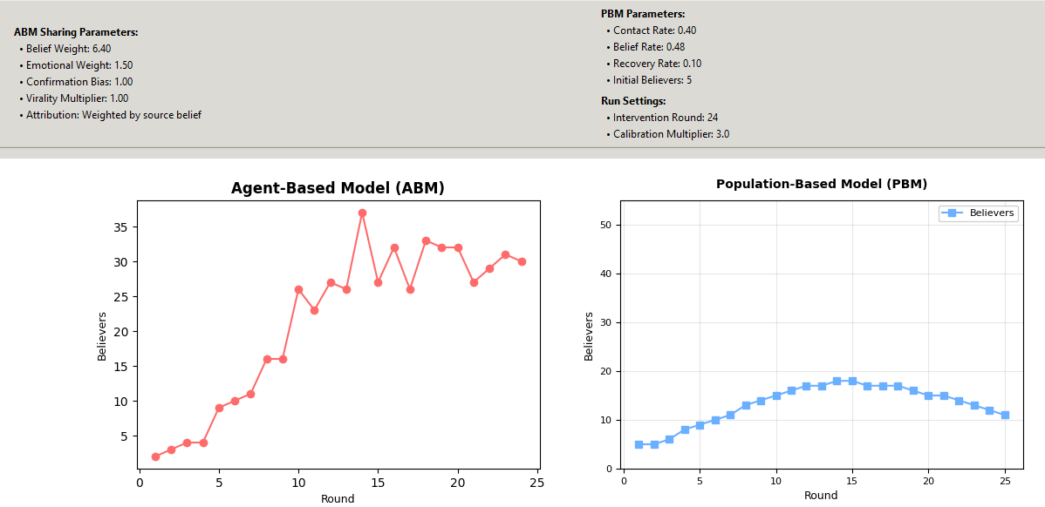
- Belief Weight: 80%. PBM Belief Rate: 80%. Other Parameters: 0
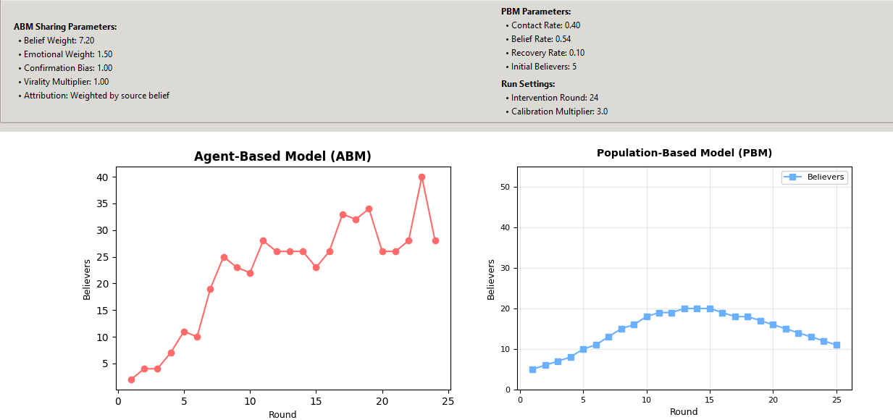

- Belief Weight: 100%. PBM Belief Rate: 100%. Other Parameters: 0
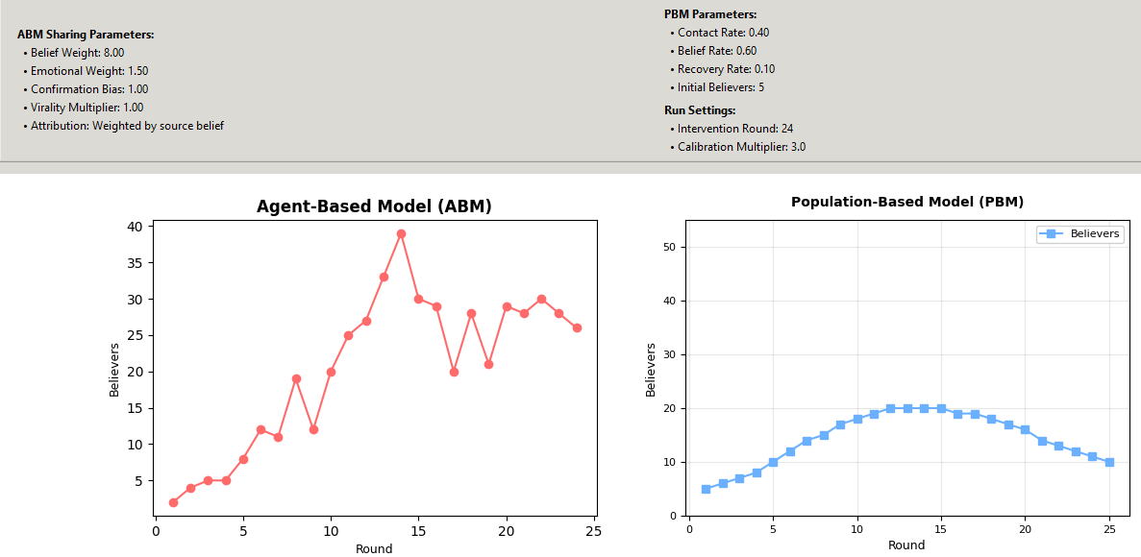

5. Equations:
1. Population-Based Model Equations
1.1 Infections Equation
$$ExposureRate =\frac{ContactRate ×BeliefRate ×S ×I}{N}$$

$$NewBelievers = min\left(ExposureRate, S ×Max_Belief\right)$$

* S: Susceptible, I: Infected/Believers, N: Total population
* ContactRate: Parameter that controls how often a susceptible person interacts with a believer
* BeliefRate: Parameter that controls the probability of a susceptible person becomes a believer after an interaction.

Function: This is the core infection dynamic
Constant 0.3 is the Maximum new believer ratio, which prevent more than 30% of the susceptible population from converting into believers from susceptible in a single round.

1.2 Recoveries

$$Recoveries = RecoveryRate ×I$$

RecoveryRate: Parameter that controls the fraction of believers who recover each round.
I: Infected/Believers

Function: Calculates the number of believers who stop believing (become "Recovered" or immune) in one round.

2. Agent-Based Model Equations

2.1 Agent Belief Probability ($P_{believe}$)

The belief probability relies on several traits listed down below:

a. Base Probability ($P_{base}$)

$$P_{base}=β_{W}∙W_{topic} + γ_{js}∙J_{s} + ε_{P_{base}}$$
Variables:
* $W_{topic}$ (Topic Weight), $J_{s}$ (Juiciness score, 0.0-1.0).
Constants:
* $ε_{P_{base}}$: 0.20
* $β_{W}$: 0.15
* $γ_{js}$: 0.10
Function: The baseline belief chance from the news itself.

b. Trait Influence (T_i)

$${T_{i}}_{\left(t\right)} = β_{T1 }∙ CB_{\left(t\right)}+ β_{T2}∙ES_{\left(t\right)} ∙(W_{topic}+η_{T} ∙{J_{s}}_{\left(t\right)}) + β_{T3}×TL_{\left(t\right)}$$
Constants:
* B1, B2, B3: 0.4, 0.3, 0.2 from config.py
* $η_{T}:0.2$
B1: CB Weight (Agent's Confirmation Bias).
B2: ES Weight (Agent's Emotional Susceptibility).
B3: TL Weight (Agent's Trust Level).

Function: Calculates how much an agent's personality traits influence their decision.

c. Resistance (R_agent)

$${Rs}_{agent}= B_{Rs}× CT_{(t)}$$

* B4 (Constant 0.3), CT (Agent's Critical Thinking).
Function: Calculates the agent's natural resistance to the news.

d. Pre-Social Probability (Ps*)

$${Ps}^{*} = min\left(max⁡_belief, max\left(0.0, P_{base}+ T_{i_{(t)}}- {Rs}_{agent}\right)\right)$$

Function: The agent's personal belief probability before social pressure.

e. Social Factor (F_social)
$$F_{social}= \frac{1}{\left(1 +\exp^{-\left(α_{exposure} ∙ Exposures_{(t)}\right)}\right)}$$

$α_{exposure}$: Dynamic parameter, 0.7 to 1.0.
$Exposures_{(t)}$: Number of agent's neighbors who are sharing over time.

Function: A sigmoid function (exp is e^{x}) that models social pressure. The more neighbors (Exposures) who are sharing, the closer this value gets to 1.

f. Fact-Check Impact ($I_{fc}$)

$${γ_{fc}}_{(t)}= \left\{\begin{aligned}γ_{BASE ∙ λ_{fc} , intervene=true} \\ γ_{BASE} , else\end{aligned}\right.$$

$$I_{fc}=\left\{\begin{aligned}γ_{fc}∙f{c_{sig}}_{\left(t\right)}∙η_{fc} , if intervene \\ γ_{fc}∙f{c_{sig}}_{\left(t\right)}∙β_{fc}, else\end{aligned}\right.$$

Constants:
* $γ_{BASE}$: 0.3, $λ_{fc}$: 2.5, $η_{fc}$: 1.5, $β_{fc}:0.8$

Variables:
$fc_{sig}$: Agent's trait

Function: Calculates the strength of an agent's fact-checking, which is amplified by an intervention.
g. Belief Probability (P_believe)

$$P_{believe} = max\left(0.0, \left(F_{social}× {Ps}^{*}\right)- I_{fact_{check}}\right)$$

Function: The final probability that an agent will adopt the belief this round.

h. ABM Social Density

$$Density=\frac{AvgDegree}{N-1}$$
- AvgDegree: The average number of connections (neighbors) an agent has in your network. It is calculated by taking the mean of all agent degrees.
- N: The total number of agents (nodes) in your simulation (e.g., 50).
- N - 1: The maximum possible number of connections a single agent could have (if they knew everyone else).
i. PBM Contact Rate Scaling
$$ContactRate_{new}=ContactRate_{original} ∙(Multiplier ∙Density)$$
$ContactRate_{original}$: The base contact rate set by the user via the GUI slider.
Multiplier: The "Calibration Multiplier" set by the user via the GUI slider (default 3.0).
Density: The calculated density of the ABM network , derived from the average degree

2.2 Agent Belief Decay

$$B_{t+1}= B_{t}× exp\left(-\left(lambda_{decay}× DecayMod\right)\right)$$

Function: Models an agent "forgetting" or losing interest over time.

* B_t: Agent's belief at the current round,
* lambda_decay: Belief decay constant (from config.py, modified by juiciness/intervention),
* DecayMod: A modifier $(max(0.6, 1.0 - (Exposures / 8)))$ that slows decay if neighbors are still sharing. (8 = Max_effect)

2.3 Agent Sharing Probability (P_share)
The sharing probability relies on several traits listed down below:

a. Sharing Score (S_score)

$$S_{score}= \left(alpha× B\right)+ \left(beta_{EMO}× ES\right)+ \left(beta_{CONF}× CB\right)+ \left(delta_{JUICE}× J\right)- \left(eta_{CRIT}× CT\right)+ Offset$$

Function: Calculates a "sharing score" based on belief and traits.

Variables:
- alpha, beta_EMO, beta_CONF, delta_JUICE: These are the GUI-controlled parameters (Belief Weight, Emotional Weight, etc.).
- B: Agent's current belief (0.0 to 1.0).
- ES, CB, CT: Agent's traits.
- J: Global Juiciness (0.0 to 1.0).
- eta_CRIT, Offset: Constants (2.5 and -1.0).
b. Final Sharing Probability (P_share)

$$P_{share}= \left(\frac{1}{1 + exp\left(-S_{score}\right)} \right)× max\left(0.0, B\right)$$

Function: Runs the score through a sigmoid function to get a probability, then multiplies by belief (so an agent with 0.0 belief cannot share).

c. Intervention Effect
$$P_{share}= P_{share}× γ_{intervene} \text{ if intervention}$$
$γ_{intervene}$: 0.45
Function: If an intervention is active, it reduces the sharing probability by 55%.

List of Constants
1. Global Configuration Constants (config.py)
- THETA_B = 0.5 (Base Belief Threshold)
- THETA_S = 0.7 (Base Sharing Threshold)
- BASE_GAMMA = 0.3 (Base Fact-Check Effectiveness)
- LAMBDA_DECAY = 0.1 (Base Belief Decay Rate)
- BETA1 = 0.4 (Weight for Confirmation Bias)
- BETA2 = 0.3 (Weight for Emotional Susceptibility)
- BETA3 = 0.2 (Weight for Trust Level)
- BETA4 = 0.3 (Weight for Critical Thinking)

2. Agent Traits
- CB: Confirmation Bias (The agent's trait, 0.0 to 1.0)
- ES: Emotional Susceptibility (The agent's trait, 0.0 to 1.0)
- TL: Trust Level (The agent's trait, 0.0 to 1.0)
- CT: Critical Thinking (The agent's trait, 0.0 to 1.0)
- FactCheckSignal: The agent's base trait for fact-checking (0.0 to 1.0)

3. ABM Equation Variables
- W_topic: The global Topic Weight (from config.py, e.g., 1.0, 1.5).
- J: The global Juiciness score (from 0.0 to 1.0, based on context).
- B: The agent's current Belief (a value from 0.0 to 1.0).
- Exposures: The number of an agent's neighbors who are currently sharing.
- P_base: The calculated Base Probability of belief from the news itself.
- T_influence: The calculated Trait Influence (the belief bonus from an agent's personality).
- R_agent: The calculated Resistance (the belief penalty from an agent's critical thinking).
- P_star: The calculated Pre-Social Probability (the agent's belief before social pressure).
- F_social: The calculated Social Factor (the belief bonus from social pressure).
- gamma: The calculated Fact-Check Effectiveness, which increases during an intervention.
- I_fact_check: The final Fact-Check Impact (the total belief penalty from fact-checking).
- DecayMod: The Decay Modifier that slows belief decay if neighbors are still sharing.
- S_score: The final Sharing Score calculated before being turned into a probability.
4. Sharing Equation Constants
ALPHA = 3.0 (Default Belief Weight for sharing)
ETA_CRIT = 2.5 (Critical Thinking penalty)
OFFSET = -1.0
The most important one is OFFSET = -1.0. This is a negative starting point. It means an agent with 0 belief and 0 traits has a negative score and will not share
The ALPHA and ETA_CRIT values are large "levers" that make belief a powerful reason to share and critical thinking a powerful reason not t
